Services :

- Workplace Assessments

Overview
The most complex variable in any organization is human behavior. Our Forensic Psychological Workplace Assessments provide organizations with a scientific, independent evaluation of the psychological and behavioral health of their workforce. By utilizing validated psychometric tools and forensic psychology principles, we help management look beneath the surface to identify behavioral risks, optimize cognitive performance, and ensure a secure, resilient, and ethically sound workplace.

Core Psychological Assessment Modules
We utilize advanced psychological methodologies to provide objective data on human performance and organizational culture:
- Forensic Psychometric Profiling (Personality & Behavior): Moving beyond standard personality quizzes, we utilize validated forensic tools to assess deep-seated behavioral traits, including emotional intelligence, risk tolerance, and susceptibility to unethical behavior. This is crucial for high-stakes hiring, leadership development, and identifying potential culture-clashes.
- Cognitive & Behavioral Performance Analysis: We evaluate the psychological drivers behind employee performance. By assessing cognitive flexibility, decision-making capabilities under pressure, and problem-solving styles, we help organizations align the right psychological profiles with specific operational roles.
- Workload, Stress & Cognitive Capacity Assessments: Burnout is a profound organizational risk. We measure cognitive load and psychological resilience to ensure optimal resource allocation. This assessment helps prevent severe fatigue, reducing the risk of critical errors and safeguarding employee mental well-being.
- Integrity & Counter-Productive Work Behavior (CWB) Audits: A specialized psychological evaluation designed to detect propensities for rule-breaking, insubordination, internal fraud, or hostility. This proactive screening protects your organization's assets and reputation from internal threats.
- Leadership Competency & Succession Dynamics: An evidence-based psychological evaluation of future leaders, focusing on their capacity for empathy, strategic cognition, and crisis management, ensuring your organization’s future is in psychologically capable hands.
- Workplace Conflict & Risk Escalation Assessment: When internal disputes arise, we provide an objective, psychological analysis of the individuals involved to determine the root cause of the conflict, the risk of escalation, and the most effective psychological interventions.

Strategic Value for Your Organization
These assessments transform subjective "gut feelings" about personnel into empirical, defensible data.
- Predictive Risk Mitigation: Identify potential behavioural issues from compliance failures to toxic leadership, before they manifest into costly organizational crises.
- Legally Defensible Data: Ensure that decisions regarding promotions, terminations, or conflict resolutions are backed by standardized, unbiased psychological evaluations that hold up under legal or regulatory scrutiny.
- Enhanced Operational Resilience: Build teams that are not only skilled but psychologically equipped to handle the specific stressors of your industry.

Who Needs This Service?
- Corporate Leadership & Boards: To ensure executive teams possess the necessary psychological resilience and ethical foundations for robust governance.
- Legal Counsel & Investigators: To obtain independent psychological evaluations during internal disputes, harassment claims, or regulatory compliance reviews.
- HR & Compliance Departments: To validate hiring and promotion decisions with objective psychological data, removing unconscious bias from human capital management.
- Banking & High-Security Sectors: To satisfy stringent security protocols by ensuring personnel in sensitive roles meet rigorous psychological reliability standards.

Why Choose Forensic Talents INDIA ?
- Clinical & Forensic Rigor: We do not rely on pop-psychology; our assessments are rooted in established forensic psychological science and validated psychometric frameworks.
- Discretion & Data Security: Psychological data is highly sensitive. We maintain absolute confidentiality and strict adherence to data protection standards.
- Actionable Organizational Intelligence: We translate complex psychological profiles into clear, actionable strategies that integrate seamlessly into your business objectives and legal compliance requirements.

Professional Forensic Training & Capacity Building

Overview
In an era where technology-driven crime outpaces traditional security measures, specialized knowledge is the only viable defense. Forensic Talents INDIA LLP provides elite, research-backed training programs designed to empower professionals across the legal, financial, and corporate spectrum.
Our programs bridge the gap between academic theory and field application, ensuring that stakeholders can identify, preserve, and utilize evidence with scientific precision and legal defensibility.

Targeted Training Tracks

1. Law Enforcement & Judiciary
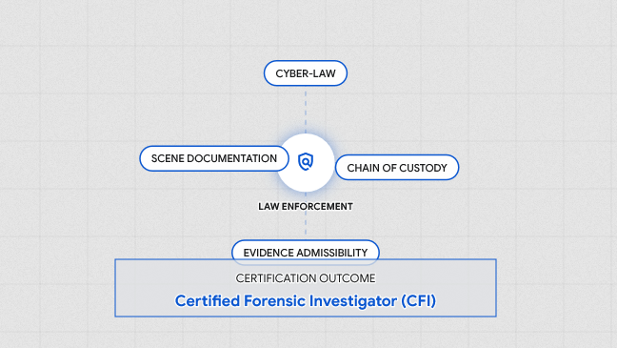
- Evidence Integrity & The New Legal Framework (BSA).
- Focus: Advanced crime scene management, biological evidence preservation, and digital forensics. Special emphasis on ensuring evidence admissibility under the Bhartiya Sakshya Adhiniyam (BSA).
- Outcome: Officers and legal professionals equipped to handle high-sensitivity cases with zero-error protocols.

2. Banking & Financial Institutions
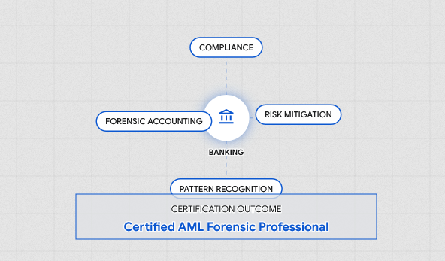
- Document Security & Fraud Detection.
- Focus: Signature and handwriting verification, detection of sophisticated alterations in negotiable instruments, and identifying "deep-fake" identities in KYC processes.
- Outcome: Reduced financial risk and enhanced internal audit capabilities against white-collar crime.

3. Corporate & Security Agencies
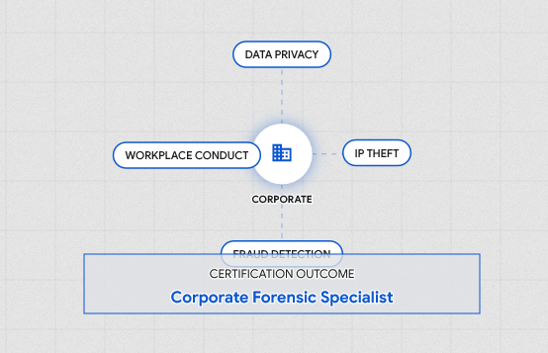
- Internal Investigation & Workplace Integrity.
- Focus: Training HR and security heads in forensic interviewing, employee vetting techniques, and identifying digital footprints of intellectual property theft.
- Outcome: A proactive security culture that deters misconduct and protects organizational assets.

4. Academics, Researchers & Interns
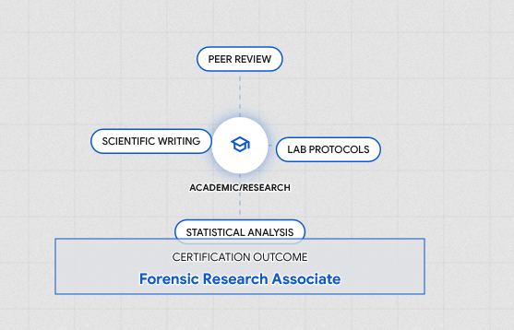

Overview
The future of forensic science relies on the educators and researchers who shape it. Forensic Talents INDIA LLP recognizes that being a brilliant scientist does not automatically translate to being an effective educator or a collaborative researcher.
This specialized program is designed for university faculty, PhD scholars, and ambitious interns. We bridge the gap between textbook theory and laboratory reality, equipping academic professionals with advanced analytical skills, modern teaching methodologies, and the interpersonal tools needed to build thriving academic-industry ecosystems.

Core Curriculum & Training Modules

1. Advanced Analytical Techniques & Research Methodology
We elevate laboratory competency to meet international publishing and evidentiary standards.
- Instrumentation Mastery: We move beyond theoretical knowledge to provide intensive, hands-on experience with the complete forensic analytical lifecycle. Our training ensures researchers and interns can confidently manage every step of the scientific process, from the moment evidence enters the lab to the final signature on the report.
- Research & Publication Rigor: Training on designing bulletproof research methodologies, statistical validation of forensic data, and navigating the peer-review process for high-impact forensic journals.
- Evidentiary Compliance: Ensuring all research and lab practices align with the latest legal frameworks, including the Bhartiya Sakshya Adhiniyam, preparing researchers for real-world legal scrutiny.

2. Pedagogical Innovation (Teaching Excellence)
Forensic science is captivating, but traditional lectures often fail to engage modern learners. We train academics to become dynamic educators.
- Engaging the Modern Student: Strategies for translating complex biochemical or legal concepts into highly engaging, interactive formats that resonate with a younger, digitally native audience.
- Curriculum Modernization: Guidance on updating university syllabi to reflect the realities of contemporary crime, moving beyond outdated case studies to focus on current digital and chemical forensic challenges.
- Simulation-Based Teaching: Training educators on how to design, stage, and grade realistic mock crime scenes and moot court exercises within a university setting.

3. Experiential Learning & Practical Exposure
Theory without practice is a liability in forensics. We provide the blueprint for integrating field realities into academic settings.
- The "Chain of Custody" Experience: Practical workshops on the seamless transition of evidence from the crime scene, through the laboratory, and into the courtroom.
- Case-Study Deconstruction: Analyzing closed Indian forensic cases to teach students how to identify analytical errors, cognitive biases, and procedural flaws.

4. Professional Dynamics & Mentorship
A successful academic career requires navigating complex professional relationships and fostering collaborative environments.
- Building the Mentor-Protégé Relationship: Frameworks for establishing professional boundaries, setting academic expectations, and guiding students and interns toward successful forensic careers without compromising objectivity.
- Industry-Academia Linkages: Training researchers and faculty on how to network with private laboratories, law enforcement agencies, and corporate sectors to secure grants, internships for their students, and collaborative research projects.
- Forensic Ethics & Integrity: Cultivating a culture of absolute scientific honesty, addressing issues of data manipulation, plagiarism, and the ethical responsibilities of a forensic mentor.

The Ultimate Outcome
Participants graduate from this program not just as proficient lab technicians, but as Holistic Forensic Leaders.
- For Academics: Elevated teaching evaluations, modernized syllabi, and a stronger ability to mentor future experts.
- For Researchers: The methodological confidence to operate sophisticated lab instrumentation and publish groundbreaking, legally defensible science.
- For Interns: A competitive, real-world edge that bridges the gap between their university degree and the high demands of the professional forensic job market.

Our Pedagogical Approach: "The Forensic Edge"
We reject dry, lecture-heavy formats. Our training is built on:
- Case-Based Learning: Real-world Indian case studies that challenge participants to apply forensic logic.
- Interactive Simulations: Gamified "Crime Room" scenarios designed to engage the next generation (GenZ) of forensic professionals.
- Hands-on Lab Access: Direct exposure to advanced analytical tools and forensic software.
- Certification: Industry-recognized credentials that validate the participant's specialized competency.

Why Partner with Forensic Talents INDIA LLP?
- Research-Led Instruction: Our curriculum is developed by active forensic researchers and practitioners, ensuring the content is current with the latest scientific journals and legal precedents.
- Customized Modules: We don't believe in "one size fits all." Every training program is tailored to the specific operational environment of the client, whether it’s a high-security bank vault or a research laboratory.
- Strategic Locations: With technical roots in Ahmedabad and regional expertise in Hyderabad, we are positioned to serve national and private interests across India.

Add above service on this section :
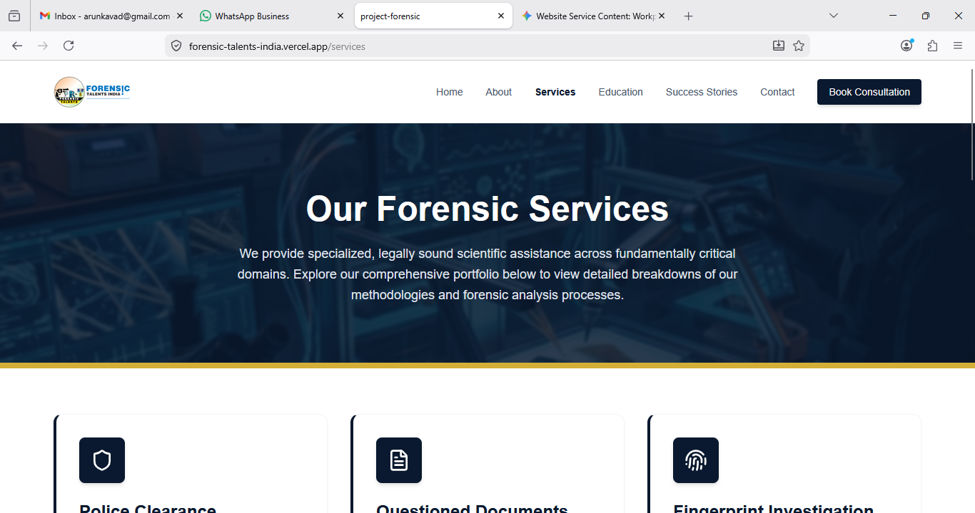

Need separate pages for :

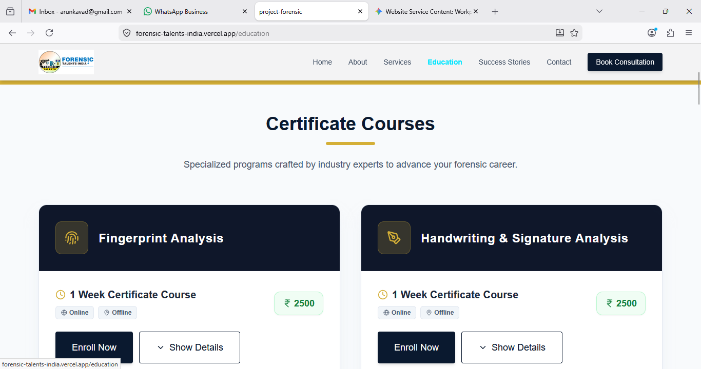

Service needed :
  - Educational
    - Courses
    - Internships
    - Training
    - Workshop
    - Other (Need writing facility for mention the special requirements or write-up)
  - Professional
    - Fingerprint Verification
    - Signature Verification
    - Handwriting analysis
    - Polygraph Testing
    - Police Clearance Certificate (PCC)
    - Crime Scene Investigation
    - Cyber Forensic
      - 63 (4) (c) Certificate BSA
      - 65 B Certificate
      - Audio Analysis
      - Video Analysis
      - Image Analysis
      - WhatsApp Chat Analysis
      - Social Media Analysis
      - Other…
    - Biological Analysis
    - Toxicology Analysis
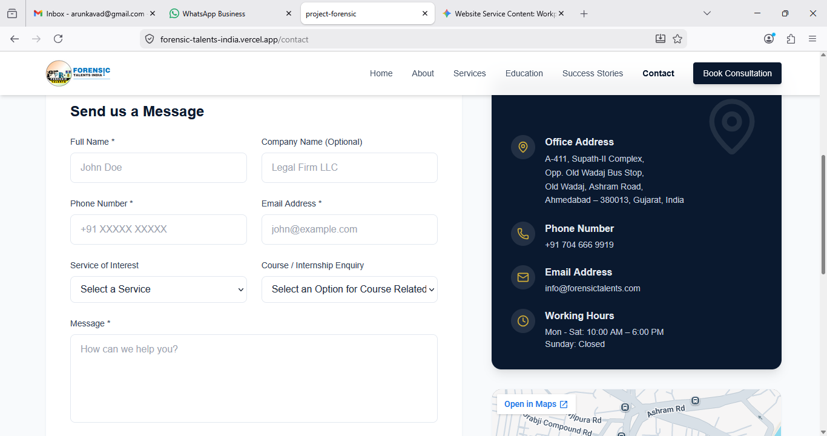

Remove Success Story from Website.

In Contact us :
Address :
Register Office : A-19, Narayan Park Society, Nikol, Ahmedabad, Gujarat, INDIA

Corporate Office :
HEAD Office : A-411, Supath-II Complex, Opp. Old Wadaj Bus Stop, Old Wadaj, Ashram Road, Ahmedabad - 380013, Gujarat, INDIA.
Contact Number : +91 - 704 666 9919

Branch Office (Hyderabad) : B-105, Bharani Apartments, Saleem Nagar Colony, Malakpet Extension, Malakpet, Hydrabad - 500036, Telangana, India
Contact Number : +91 - 98851 14772

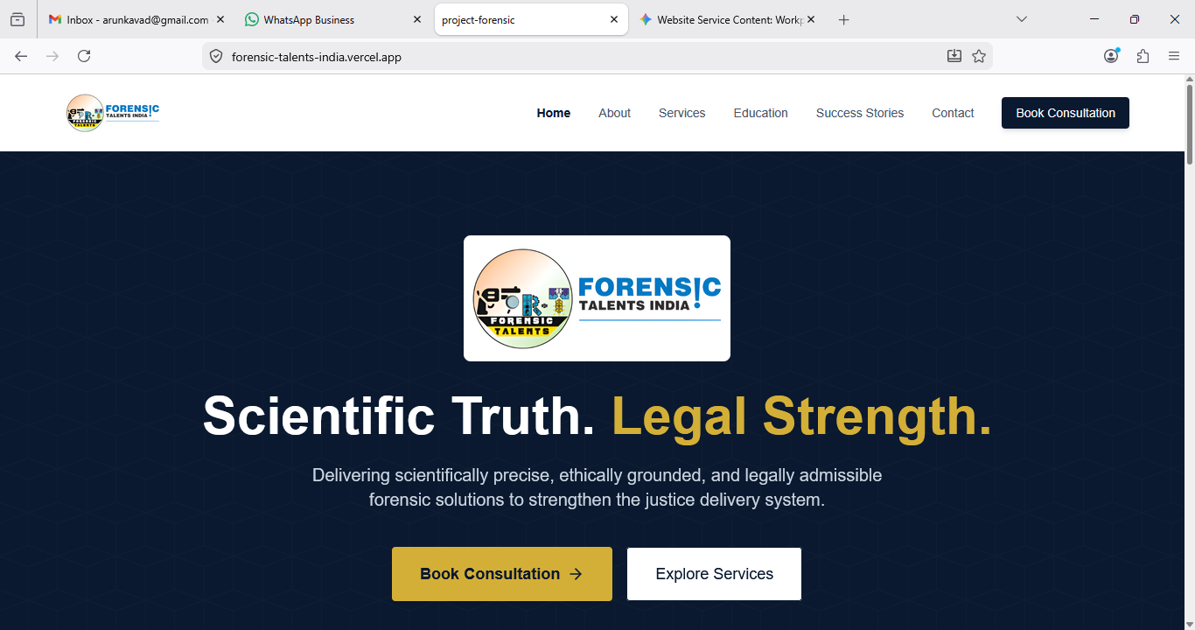


Logo :



Cyber Forensics & Digital Investigation

Focus on 63 (4) (C) Certificate - BSA ( Formerly Section 65 (B) IEA) for digital evidence….

